**Identify the data flow between the two tables**

**Identify the business keys and how the tables will be connected**

Sales Territory (Sales.SalesTerritory) and Currency Rate (Sales.CurrencyRate)

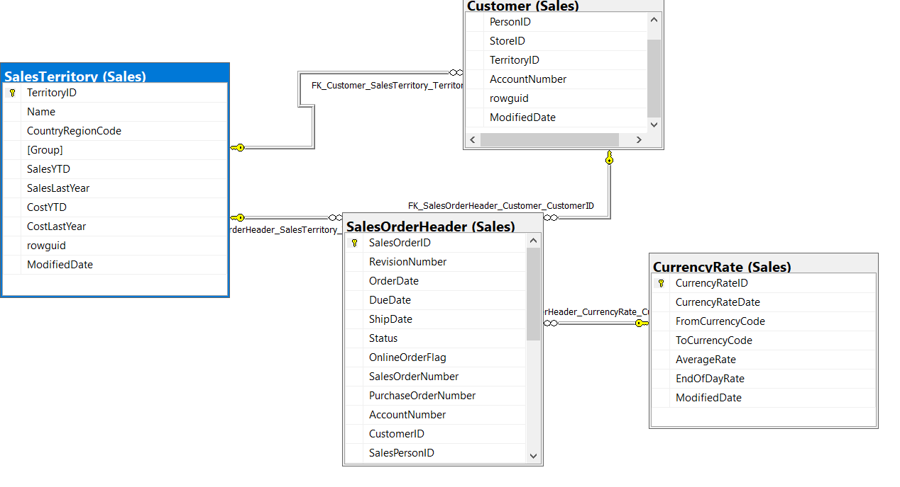

Special Offer (Sales.SpecialOffer) and Sales Order Header (Sales.SalesOrderHeader)

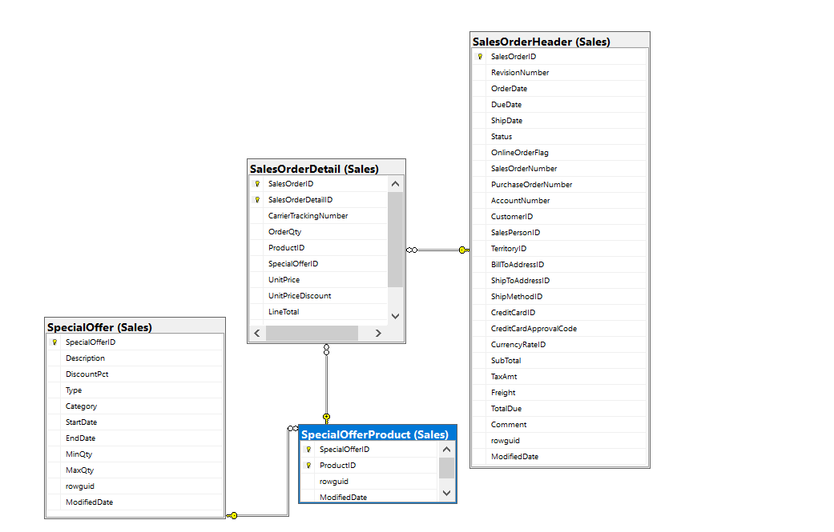

Store (Sales.Store) and Person Credit Card (Sales.PersonCreditCard)

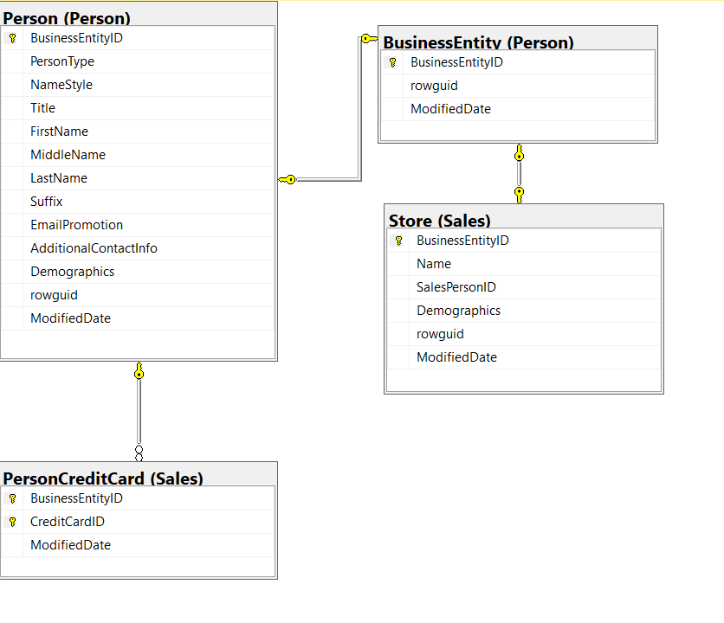

Currency (Sales.Currency) and Sales Person Quota History (Sales.SalesPersonQuotaHistory)

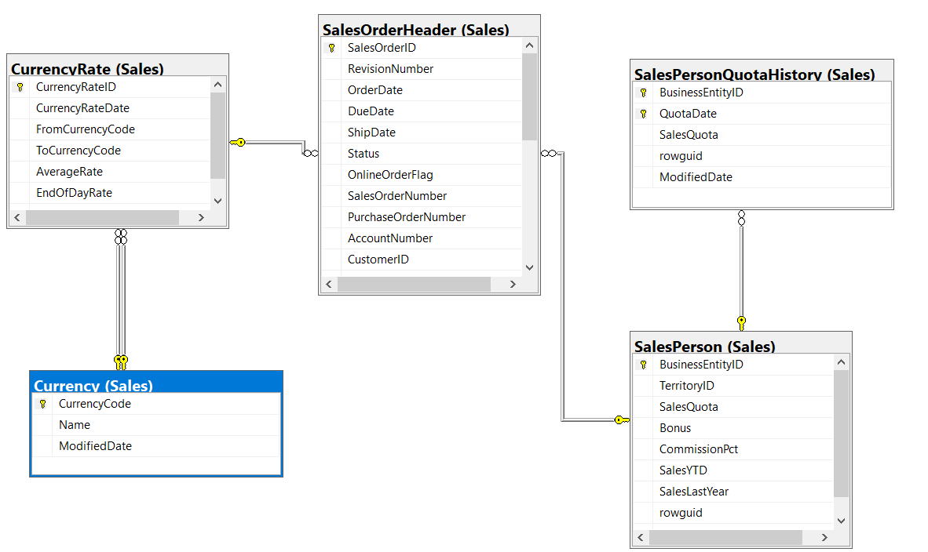

Sales Territory History (Sales.SalesTerritoryHistory and Special Offer (Sales.SpecialOffer)

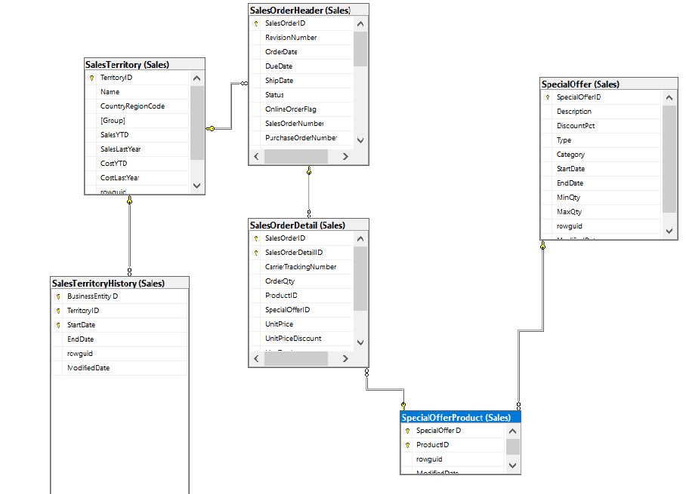

Sales Order Header (Sales.SalesOrderHeader) and Sales Person (Sales.SalesPerson)

